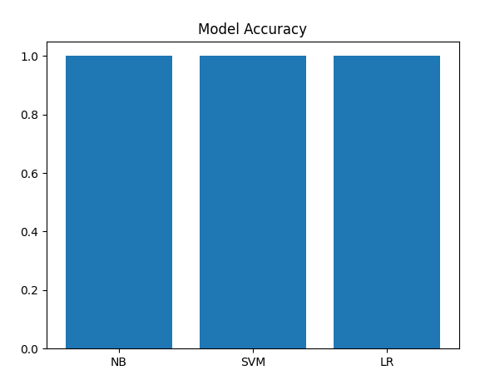
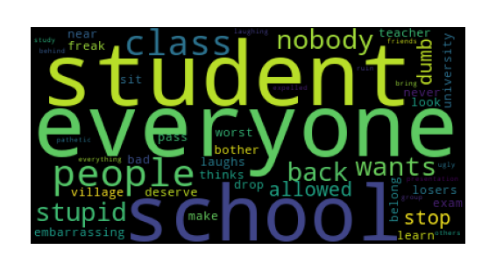

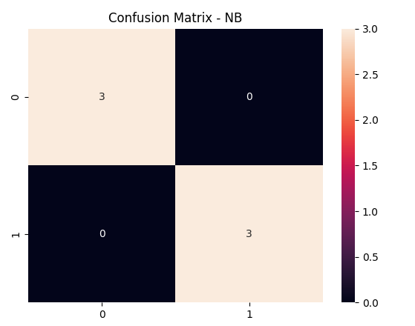
=====================================
Dataset shape: (27, 2)

NB Accuracy: 1.0
precision recall f1-score support

HATE 1.00 1.00 1.00 3
NON-HATE 1.00 1.00 1.00 3

accuracy 1.00 6
macro avg 1.00 1.00 1.00 6
weighted avg 1.00 1.00 1.00 6

SVM Accuracy: 1.0
precision recall f1-score support

HATE 1.00 1.00 1.00 3
NON-HATE 1.00 1.00 1.00 3

accuracy 1.00 6
macro avg 1.00 1.00 1.00 6
weighted avg 1.00 1.00 1.00 6

LR Accuracy: 1.0
precision recall f1-score support

HATE 1.00 1.00 1.00 3
NON-HATE 1.00 1.00 1.00 3

accuracy 1.00 6
macro avg 1.00 1.00 1.00 6
weighted avg 1.00 1.00 1.00 6
======================================
The experimental results show that all three models—Naive Bayes (NB), Support Vector Machine (SVM), and Logistic Regression (LR)—achieved perfect performance, each reaching an accuracy of 1.00 (100%) on the test set. The evaluation was conducted on 6 test samples, with an equal class distribution (3 HATE and 3 NON-HATE instances).
According to the classification reports, all models obtained precision = 1.00, recall = 1.00, and F1-score = 1.00 for both classes. The confusion matrix for Naive Bayes further confirms this performance, showing 3 correctly classified HATE samples and 3 correctly classified NON-HATE samples, with 0 misclassifications. This indicates that the model perfectly separated the two classes without any errors.
The WordCloud visualization highlights that the dataset contains strongly distinguishable keywords such as “stupid,” “dummy,” “losers,” and “embarrassing,” which are highly indicative of the HATE class. This clear lexical separation makes the classification task relatively easy for machine learning models, especially when combined with text vectorization techniques.
However, similar to the previous experiment, these results should be interpreted with caution. The test set is extremely small (n = 6), which increases the risk of overfitting and reduces the reliability of the evaluation. The models may simply memorize patterns rather than learn generalizable features.
In conclusion, although all three models achieved 100% accuracy, there is no meaningful performance difference among them. To obtain more reliable results, future work should involve a larger and more diverse dataset, along with more robust evaluation methods such as cross-validation.

